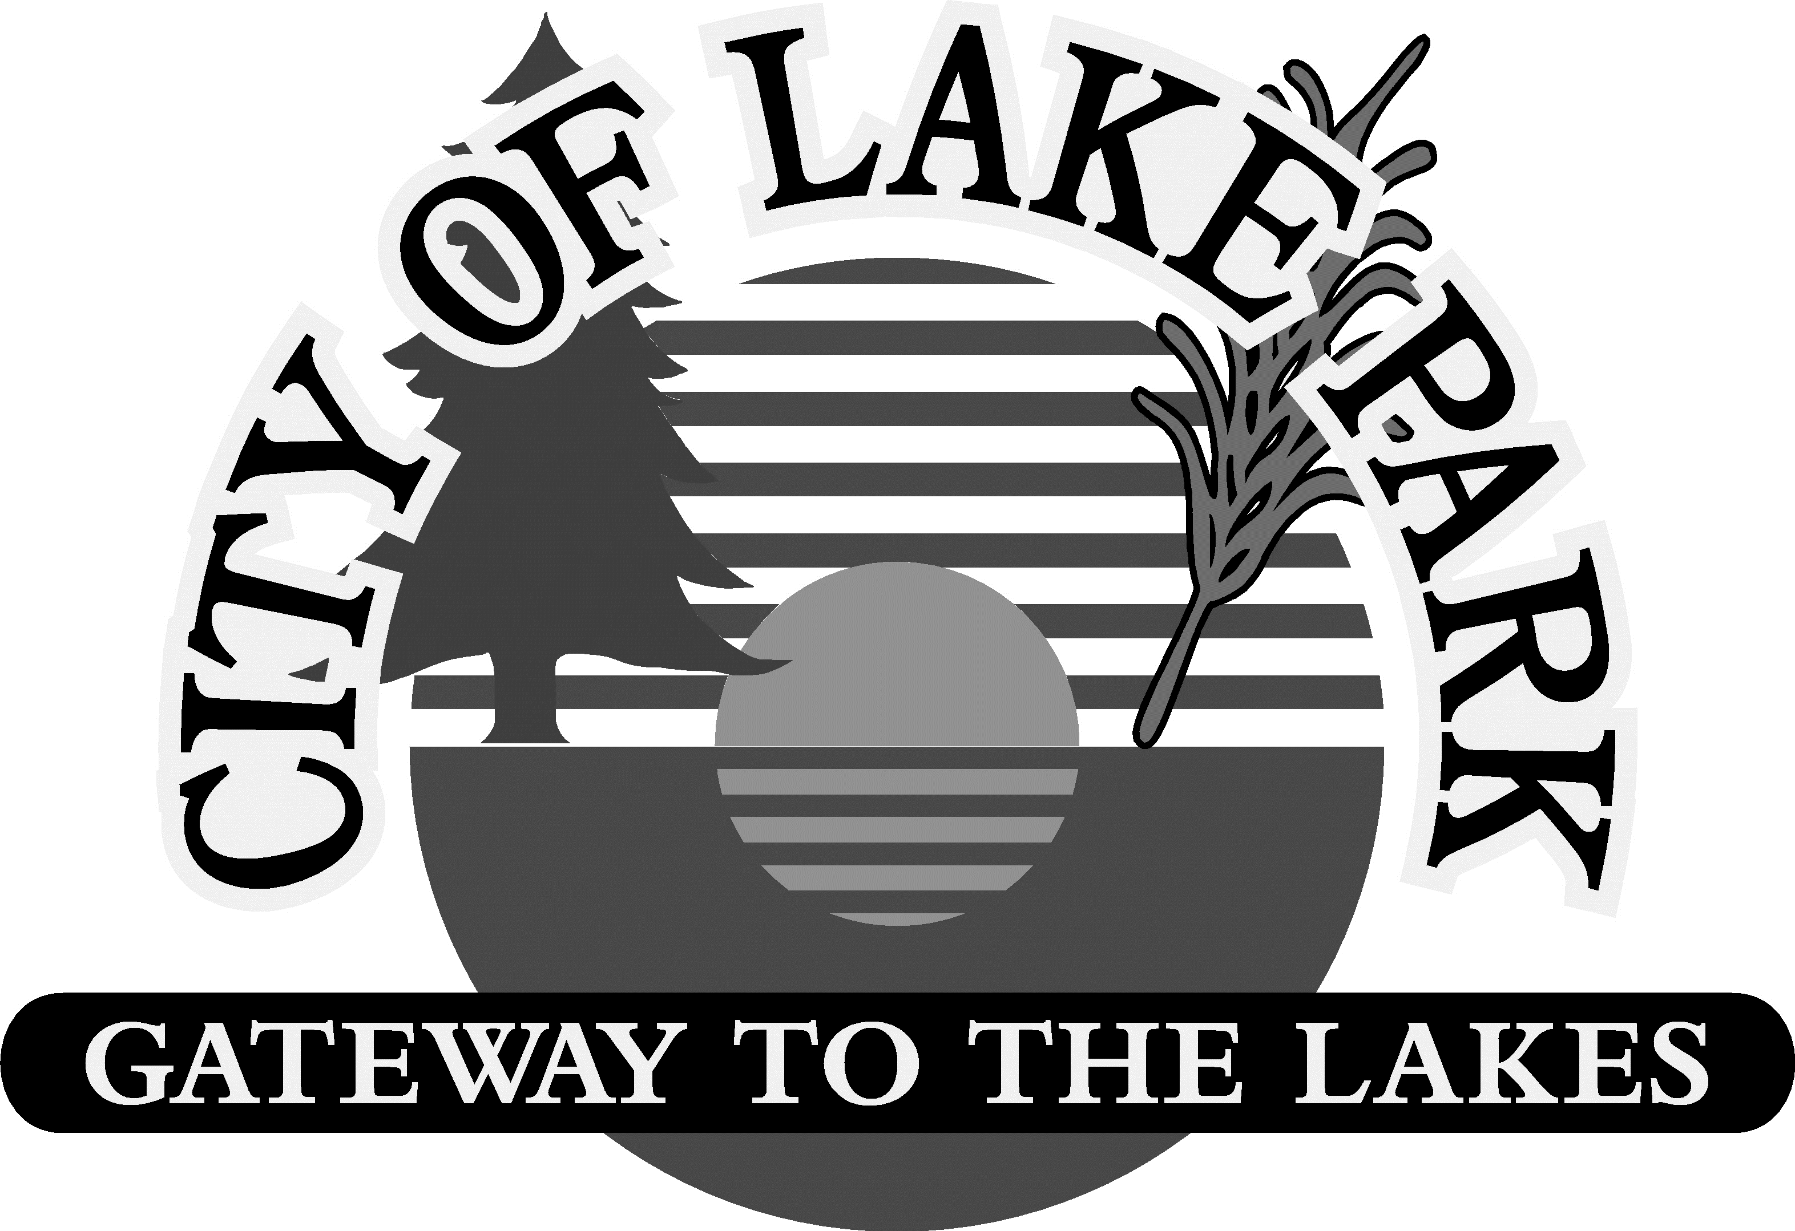
LAKE PARK CITY COUNCIL MINUTES Page 34
2032 2nd Street
January 12, 2026 - 7:00 p.m.

- CALL TO ORDER
- Meeting called to order by Mayor John Beaudine at 7:00 p.m. at the Lake Park City Center.

- ROLL CALL
- Members Present: John Beaudine, Andy Krause, Andrea Pollock, Britney Ronning, and Keith Zachariason
- Members Absent:
- Staff: Chris Bromeling, Brady Burnside, Tammy Charbonneau, Todd Frank, Sarah Mikkelsen, and Carly Olson
- Contracted: Dylan Ramstad Skoyles
- Media:
- Guests: Jonathan Donovan, Doug Moeller, Samara Olson, Mike Seifert, and Nicci Seifert

- ADDITIONS AND/OR REMOVALS
- Swearing in of Firefighters During Public Forum

- PUBLIC FORUM & CORRESPONDENCE
  - Swearing in of Firefighters – Samara Olson and Jonathan Donovan have completed the probationary period with Lake Park Fire Department and completed 140 hours of Firefighter I, Firefighter II, and Hazmat training, along with more than 36 hours of in-house training. William Merriam also completed probationary period and above referenced training, however, was not present.

E. CONSENT AGENDA
- Minutes of December 8th, 2025 Council Meeting
- Minutes of TNT Meeting, December 8th, 2025
- Bills
M/S/CU: Ronning/Zachariason to approve Consent Agenda.
Roll Call: Beaudine – Aye, Krause – Aye, Pollock – Aye, Ronning – Aye, Zachariason - Aye

F. ADDITIONAL BILLS
1. Additional Bills
M/S/CU: Zachariason/Ronning to approve additional bills.
Roll Call: Beaudine – Aye, Krause – Aye, Pollock – Aye, Ronning – Aye, Zachariason - Aye

G. STAFF REPORT
1. EDA Report – Chris Dosh is the new EDA member. After obtaining Council approval, Chris will be sworn in at next month’s meeting.
M/S/CU: Pollock/Krause to approve Chris Dosh as new EDA member.
2. Brandon Reber, Moore Engineering
3. Brenda Seley, Nutrition Coordinator
  - 2025 Summary Report
4. Dave Coufal, Fire Chief
  - Fire Calls – 1 medical call and 1 motor vehicle accident.
  - Training Coming Up – Sectional schools and continued education in Moorhead and Mahnomen.
- Carly Olson, Municipal Liquor Manager
  - 2025 Summary – 2025 was a profitable year, almost $50,000. Inventory went well.
  - We Fest Karaoke Roundup – Signed up for competition and the first round starts February 21st at the Lake Park Liquor Store. There will be 4 rounds, and the winner will go to the Shooting Star, and the final winner will sing the National Anthem at We Fest. Received We Fest tickets to give away to winners.
- Brady Burnside, Police Chief
  - Calls for Service – Since the last City Council meeting there have been:
    - 2 dog at large calls; one was unfounded and the other was the result of a broken fence due to a car accident.
    - 7 traffic stops
    - 4 traffic citations
    - 1 domestic assault arrest by the County
    - 3 medicals
Page 35

    - 2 juvenile calls; one resulted in shelter care placement
    - 5 welfare checks
    - 2 crashes
    - 3 assists to the County and State Patrol
    - 8 parking complaints, mostly involved being snowed in; individuals were quick to move the vehicles once warnings were handed out
    - 1 city ordinance violation
  - Training – Preparing for State’s annual post-audit confirming all training and policies are in place.
  - Shop With a Cop – Sponsored by Detroit Lakes Police Department and Walmart. Lake Park and Audubon police brought 6 kids shopping. Each kid received $125 to spend on their family. This was very rewarding.
  - Quarterly Regional Chief Association Meeting - Burnside was re-elected as Secretary/Treasurer.
  - Additional Activity – Completed 15 hours patrolling at the school and 8 hours of community outreach.
- Todd Frank, Utility & Public Works Superintendent
  - Activity – Snow removal, Christmas decorations, work in the shop on the floor drain, and starting to work on Gas qualification testing.
- Dylan Ramstad Skoyles, City Attorney
9. Sarah Mikkelsen, City Clerk-Treasurer
a. Budget Fund Summaries
b. Pay Equity Report
M/S/CU: Zachariason/Ronning to approve submitting the Pay Equity Report to the State with a change for one employee from female to male.
  - Year-end Items – Mikkelsen working on several year-end paperwork.
- Council Reports
  - Zachariason – Member of Becker County Recreational Advisory Board. The Heartland Trails will be coming through the North end of town and Graffiti bridge. If anyone is interested, Zachariason can provide the web page for more information.

H. NEW BUSINESS
1. 2026 Official Information – Updated sheet reflecting Liquor Store Manager as Olson instead of Krause.
M/S/CU: Zachariason/Pollock to approve updated 2026 Official Information.
- Resolution 26-101 – City Depository & Newspaper
M/S/CU: Zachariason/Ronning to approve Resolution 26-101: City Depository & Newspaper.
Roll Call: Beaudine – Aye, Krause – Aye, Pollock – Aye, Ronning – Aye, Zachariason – Aye
- Resolution 26-102 – Limited Use Permit
M/S/CU: Ronning/Pollock to approve Resolution 26-102: Limited Use Permit.
Roll Call: Beaudine – Aye, Krause – Aye, Pollock – Aye, Ronning – Aye, Zachariason - Aye
- Audit Engagement Letter – This is the 4th year of the 5 year contract.
M/S/CU: Zachariason/Ronning to approve Audit Engagement Letter.
Roll Call: Beaudine – Aye, Krause – Aye, Pollock – Aye, Ronning – Aye, Zachariason - Aye

- OLD BUSINESS
1. Road Funding – State Funding was not received. Beaudine, Mikkelsen, Frank and Reber will meet to discuss and begin working on. There was a suggestion to do only part of the roads at a time, however, this would be significantly more expensive overall. May look into whether the City is able to get a loan through the State at a low interest rate and Levy to obtain money for the roads. Preliminary information is complete and provided to Moore Engineering, and they will meet internally prior to meeting with the City Council in February.

J. OTHER BUSINESS
- Office Space: Dr. A.S. Midthune Health & Public Safey – Ad for available office space was put on Facebook and other sites.
- Pay Study – Await feedback.
- Grants/Donation
  - Polling Place Grant – The City received $727.72 for improvements to polling.
  - Arvig Donation Request – Mikkelsen submitted a donation request for $25,000. Arvig requested this be presented to them. Mikkelsen will meet with Zachariason to review wish list for the Park and Zachariason will present information.
  - Arvig Donation – Received $750 donation for the Nutrition Program.

Page 36
K. ANNOUNCEMENTS
- Lake Park Audubon Lions Club Event - January 17th, 2026, at the American Legion in Lake Park.

L. ADJOURNMENT – 7:31 p.m.

THESE MINUTES WERE OFFICIALLY APPROVED AT THE REGULAR MEETING ON FEBRUARY 9th, 2026.

_____________________________________ _____________________________________
Sarah Mikkelsen, City Clerk-Treasurer John Beaudine, Mayor

